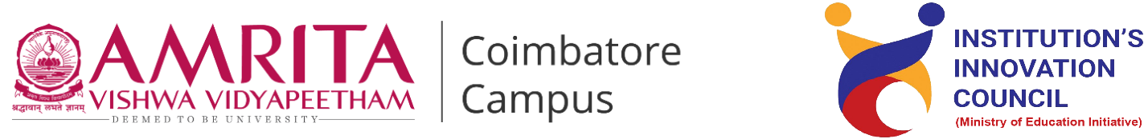

**Live-in-Labs® : Field Visit to Kalpar,Ramanathapuram**

**Activity Category :** Self – Driven Activities

**Event Title :** Live-in-Labs : Field Visit to Kalpar

**Dates :** 04-06-205 to 13-06-2025

**Occasion/Theme :** Experiential Learning

**Organized by :** Live-in-Labs, Amrita Vishwa Vidyapeetham

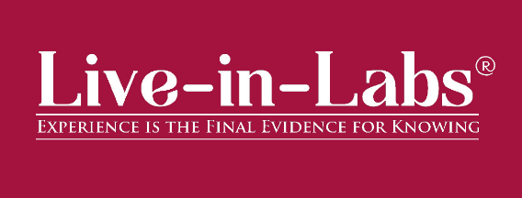

**Overview**

The Live-in-Labs® project in the village of ***Kalpar,Erwadi panchayat,Ramanathapuram*** *district, Tamilnadu* was carried out by a team of Amrita students and international students under the mentorship of ***Anand R Nair***. The focus of the visit was to address the challenge of *Scarcity of water* through innovative, sustainable, and community-driven solutions.

The team interacted with villagers, conducted surveys, and studied the socio-economic conditions to identify root causes of the problem. Based on this, solutions such as *Nanneer filtration of water* and *Solar powered Nano-filtration* were proposed. These interventions combine scientific knowledge with frugal innovation, making them both cost-effective and scalable.

The visit provided the team with hands-on exposure to applying classroom concepts in real-world contexts. Students gained valuable knowledge on design thinking, grassroots innovation, and community engagement. The collaboration between Amrita and international students enriched the process with diverse perspectives, ensuring that the solutions were both technically sound and socially acceptable.

Overall, the project demonstrated how grassroots challenges can be transformed into opportunities for innovation and entrepreneurship. The solutions identified have the potential for further prototyping, incubation, and replication in other rural contexts, aligning with the vision of IIC to foster innovation-driven impact.

**Planning & Execution**

The project was planned in advance based on the schedule prepared and submitted during the Live-in-Labs® workshop. The schedule served as a roadmap, outlining each stage of the work from preliminary study to field immersion and final reporting. In the initial phase, the team conducted a background study of the village and gathered secondary data to understand the broader context of the problem. This was followed by structured planning of surveys, community interactions, and technical assessments, all aligned with the timelines agreed upon.

Ref:- (RM-resource map,TA-thematic area,VD-venn diagram,IO-inflow outflow , PT – Problem Tree , P – Persona , S – Scenario )

Day 1:

04-06-2025 , Wednesday :

9AM – 11AM : Meet village co-ordinator, village head .

11AM – 1PM : Village walk(identify change champion etc) .

1PM – 2PM : LUNCH

2PM – 5PM : AEIOU(Observations) thematic area-wise list of resources needed

in a village

5PM-6PM : Returning to Amrita Vidyalayam.

After 6 PM : drawing resource map ,update interview questions and journal .

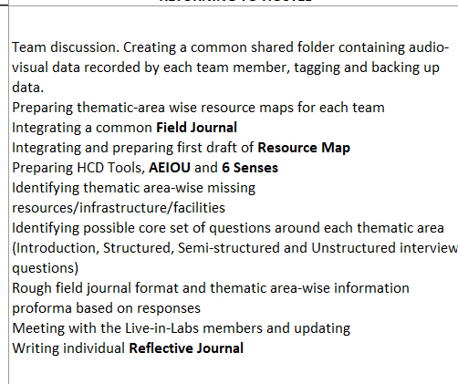

Goals / Deliverables : Integrating and preparing first draft of Resource Map .

Day 2: 05-06-2025 , Thursday

9AM – 1PM : Interview Households (focus on PRA tools) Door-to-door interview.

Structured questions for RM, VD, IO. Unstructured questions for P, S

Focusing on 8 TA.

1PM – 2PM : Lunch

2PM – 5PM : Interview visit anganwadi, ration shop, school etc . Door-to-door interview.

Structured questions for RM, VD, IO. Unstructured questions for P, S and

PT . Focusing on 8 TA.

5PM – 6PM : Returning to Amrita Vidyalayam.

After 6PM : drawing resource map ,update interview questions and journal.

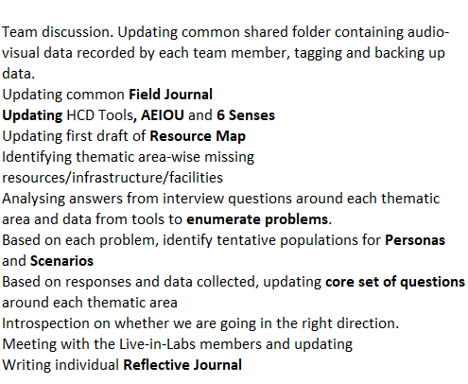

Goals / Deliverables : Updating first draft of Resource Map

Day 3: 06-06-2025 , Friday

9AM – 10AM : transect walk 1 .

10AM – 1PM : Interview Households (focus on PRA tools ) .Door-to-door interview.

Structured questions for RM, VD, IO. Unstructured questions for P, S

Focusing on 8 TA.

1PM – 2PM : Lunch

2PM – 5PM : Interview visit anganwadi, ration shop, school etc . Door-to-door interview.

Structured questions for RM, VD, IO. Unstructured questions for P, S and

PT Focusing on 8 TA.

5PM – 6PM : Returning to Amrita Vidyalayam

After 6PM : journal writing/work on PRA tools interview questions.

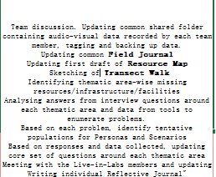

Updating first draft of Resource Map .

Day 4: 07-06-2025 , Saturday (Bakrid)

9AM – 11AM : Activities with children .

11AM – 1PM : Interview Households (focus on PRA tools) ,Door-to-door interview.

Structured questions for RM, VD, IO. Unstructured questions for P, S and PT

Focusing on 8 TA.

1PM – 2PM : Lunch

2PM – 5PM : Interview Households (focus on PRA tools) ,Door-to-door interview.

Structured questions for RM, VD, IO. Unstructured questions for P, S and PT

Focusing on 8 TA.

5PM – 6PM : Returning to Amrita Vidyalayam .

After 6PM : journal writing/work on PRA tools interview questions .

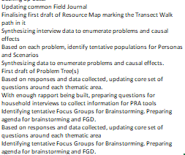

Day 5: 08-06-2025 , Sunday

9AM – 1PM : Brainstorming 1 .

1PM – 2PM : Lunch

2PM – 5PM : Focus Group Discussions .

5PM – 6PM : Returning to Amrita Vidyalayam .

After 6PM : journal / working on PRA tools interview questions .

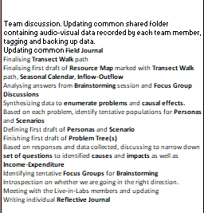

Day 6 : 09-06-2025 ,Monday.

9AM – 12PM : Based on PT draft 1, identified a Problem Population. Interview Problem

Population Households.Door-to-door interview.

Semi-structured questions for In-Exp. Unstructured questions for P, S and PT

Focusing on PT

12PM – 1PM : Empower App

1PM – 2PM : Lunch

2PM – 5PM : Based on PT draft 1, identified a Problem Population. Interview Problem

Population Stakeholders. Inside or outside village .Semi-structured

Questions, focusing on PT

After 6PM : journal / review of other PRA tools problem tree /interview questions .

Goals /

Deliverables : draft of seasonal calender , resources inflow and outflow .

Day 7: 10-06-2025 , Tuesday

9AM – 12PM : Based on PT draft 1, identified a Problem Population. Interview Problem

Population Households.Door-to-door interview.

Semi-structured questions for In-Exp. Unstructured questions for P, S and PT

Focusing on PT

12PM – 1PM : Empower App .

2PM – 5PM : Based on PT draft 1, identified a Problem Population .Interview Problem

Population Stakeholders. Inside or outside village.Semi-structured questions

focusing on PT

After 6PM : journal /review pra tools , All the PRA tools , persona and scenario , journal

Writing .

Day 8 : 11-06-2025 , Wednesday

9AM – 1PM : Brainstorming 2

2PM - 5PM : Focus Group Discussions

After 6PM : journal /persona & scenriao /problem tree , finalising the problem tree ,

journal Writing .

Day 9 : 12-06-2025 , Thursday

9AM – 10AM : transect walk 2

10AM – 12 PM : Review the leftover

12PM – 1PM : Presenting P, S, PT , Thanking Community Farewell .

2PM – 5PM : Report Writing

After 6 PM : journal / validate persona & scenriao , Finalising the transect walk ,journal

writing

Day – 10 : 13-06-2025 ,Friday

9AM – 2PM : Report Writing .

**Impact & Outcomes**

* **Innovation :** The project demonstrated how grassroots challenges can inspire innovative, frugal solutions. By integrating scientific concepts with local knowledge, the team planning to design interventions such as *Nanneer filtration of water* and *Solar powered Nano-filtration* that were low-cost, adaptable, and scalable. This process highlighted the power of student-led innovation to create practical and impactful models in rural development.
* **Design Thinking :** The outcomes of the project were achieved by following a design-thinking approach. Students empathized with villagers through surveys and discussions, defined the root problems, ideated possible solutions, and tested their feasibility with the community. This systematic method ensured that the solutions were not only technically feasible but also socially acceptable and context-specific.
* **Entrepreneurship Potential :** Several proposed solutions have the potential to evolve into entrepreneurial models or startups. For example, *Solar-Powered Desalination & Filtration Units*  can be further developed into a product or service that benefits multiple villages, creating employment opportunities while addressing community needs. This outcome aligns with IIC’s vision of nurturing student entrepreneurship and translating innovation into scalable ventures.
* **Sustainability :** The solutions emphasized long-term sustainability by making use of locally available resources and building capacity within the community. As a result, the interventions can be maintained by villagers themselves without heavy dependence on external support. This ensures that the outcomes continue to create impact even after the project phase ends.
* **Societal Impact :** The immediate impact of the project was raising awareness among community members about alternative and innovative practices. In the long run, the solutions are expected to improve living standards, reduce resource-related hardships, and strengthen the resilience of the village. The project also encouraged local youth to view innovation as a tool for solving their own challenges.
* **Collaboration and Knowledge Sharing :** A significant outcome of the project was the knowledge exchange that took place between Amrita students, international peers, and the local community. This cross-cultural collaboration enriched the learning experience, allowed multiple perspectives to be considered, and helped design solutions that were technically sound, socially relevant, and globally informed.

**Participation**

1. **Student Members** : Conducted Surveys, Identified the Problem and Designed Solutions.

* Akula Manideep (CB.SC.U4CSE24462) - Department of Computer Science and Engineering, School of Computing, Coimbatore
* Nivethitha B (CB.EN.U4EEE24132)- Department of Electrical and Electronics Engineering, School of Engineering, Coimbatore
* Swetha M (CB.SC.U4CSE24659)- Department of Computer Science and Engineering, School of Computing, Coimbatore
* Krithikk T (CB.SC.U4CYS24035)- TIFAC-CORE in Cyber Security, Coimbatore
* Sabbella Vaishnavi (CB.SC.U4CSE24363) - Department of Computer Science and Engineering, School of Computing, Coimbatore

1. **Faculty Member (Mentor)** : **Anand R Nair** *Faculty in**TIFAC-CORE* Cyber *Security* - Provided continuous guidance and supervision.

**Contribution to SDGs**

The project contributes to several United Nations Sustainable Development Goals (SDGs):

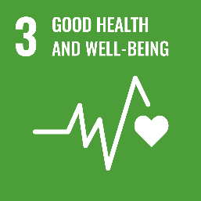

By addressing *clean drinking water , waste management , health awareness*, the project improves health outcomes for the community.

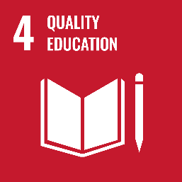

Knowledge sharing, awareness programs, and cross-cultural learning enhanced educational opportunities for both villagers and students.

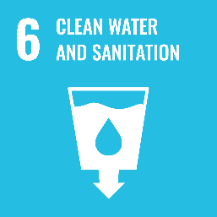

Proposed solutions such as  *water purification units, sanitation awareness drives* directly improve access to safe water and sanitation facilities.

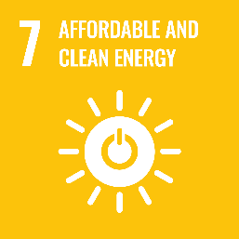

Interventions like  *solar-powered systems, waste-to-energy solutions*  promote clean and sustainable energy alternatives.

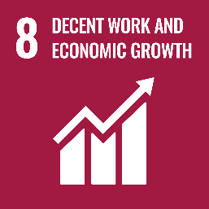

Entrepreneurial potential of the solutions encourages community-based enterprises and livelihood opportunities.

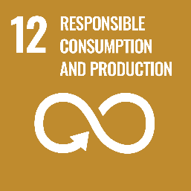The solutions emphasize frugal innovation, waste reduction, and sustainable use of resources.

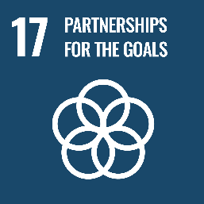

Collaboration between Amrita students, international peers, and the village community reflects strong global partnerships for sustainable development.

**Publicity**

